

MUT WEBSITE
ICT Department
[Author name] | 5/6/26 | Internet Programming 2

Initials and Surname | Student Number
T Maxhegwana | 22430210
AH Nhleko | 22411763
N Zuma | 22419409
NN Dlodlo | 22325063
LG Duba | 22416734

Content | Pages
1.Introduction | 2
2.Project overview | 2
3.Objectives of the system | 2-3
4.Problem statement | 3
5.Technologies used | 3
6.System architecture | 4
7.Sytem design | 4-5
8. Frontend Design and Implementation | 5-6
9. Backend Design and Implementation | 6-8
10. Database Design | 8-9
11. Functional Requirements | 9
12. Non-Functional Requirements | 9-10
13. Security Features | 10
14. User Interface Design | 10
15. Key Features of the Website | 10-14
16. API Endpoints | 14-15
17. Testing and Debugging | 15
18. Challenges Encountered | 15-17
19. Future Improvements | 17-19
20. Conclusion | 19

1. Introduction
The MUT ICT Department Website is a web-based information system developed to provide students, lecturers, and visitors with easy access to important information and ICT-related services. The system was designed to modernize communication within the department and improve accessibility to resources such as courses, appointments, feedback forms, events, laboratories, and support services.
The website combines frontend web technologies with backend server-side programming and database integration. It allows users to interact with the system dynamically while enabling the department to manage requests efficiently.

2. Project Overview
The project is a full-stack website application developed using HTML, CSS, JavaScript, Node.js, Express.js, and MySQL.
The website provides:
- Department information
- Course details
- Laboratory information
- Contact and feedback forms
- Appointment booking
- Helpdesk support
- Event information
- Authentication functionality
- Database storage for user submissions
- Email notifications
The system follows a client-server architecture where:
- The frontend handles the user interface.
- The backend processes requests.
- The MySQL database stores information.
- Nodemailer handles email communication.

3. Objectives of the System
The objectives of the project are:
- To provide an online platform for the MUT ICT Department.
- To improve communication between students and the department.
- To allow users to send feedback and contact messages electronically.
- To automate appointment booking.
- To provide easy access to course and laboratory information.
- To improve user experience through a modern responsive website.
- To store and manage user data using a relational database.

4. Problem Statement
The existing ICT Department website had several limitations that reduced its effectiveness and overall user experience. The website was mostly static, meaning users could only view information without interacting dynamically with the system. This limited functionality made communication and service delivery inefficient for students, staff, and visitors.
In addition, the website provided limited user interaction features, which prevented users from accessing modern online services such as smart support, automated feedback, and interactive communication tools. The system also suffered from poor responsiveness on smaller devices, causing display and usability problems on smartphones and tablets.
Another major issue was the absence of smart support features, such as chat assistance and automated help services, which made it difficult for users to receive quick assistance or guidance. Furthermore, the overall user experience design was outdated and lacked a modern, attractive, and user-friendly interface.
Therefore, there was a need to redesign and redevelop the ICT Department website into a modern full-stack web application using HTML, CSS, JavaScript, Node.js, Express, and a database system to improve functionality, responsiveness, interactivity, and overall user experience.

5. Technologies Used
Technology | Purpose
HTML5 | Structure of web pages
CSS3 | Styling and layout
JavaScript | Interactive functionality
Node.js | Backend runtime environment
Express.js | Web application framework
MySQL | Database management system
Nodemailer | Email sending functionality
CORS | Cross-origin communication
dotenv | Environment variable management
node-fetch | API requests
Multer | File upload handling

6. System Architecture
The system uses a three-tier architecture:
6.1 Presentation Layer
This layer consists of HTML pages, CSS styling, and JavaScript functionality that users interact with directly.
Examples:
- index.html
- contact.html
- courses.html
- helpdesk.html
- Feedback.html
6.2 Application Layer
This layer contains the business logic implemented using Node.js and Express.js.
Main backend file:
- server.js
Responsibilities:
- Processing form submissions
- Sending emails
- Handling API requests
- Managing authentication
- Communicating with the database
6.3 Data Layer
The MySQL database stores application data such as:
- Contact messages
- Appointment bookings
- User information
- Feedback data

7. System Design
7.1 Navigation Structure
The website contains multiple interconnected pages.
Main pages include:
- Home Page
- Courses Page
- Events Page
- FAQ Page
- Feedback Page
- Helpdesk Page
- Laboratories Page
- Contact Page
- Login Page
The navigation bar allows users to move between pages easily.

7.2 User Flow
- User opens the website.
- User navigates to the desired page.
- User fills in forms if necessary.
- Backend validates and processes data.
- Data is stored in the database.
- Email notifications are sent.
- User receives confirmation.

8. Frontend Design and Implementation
8.1 HTML Structure
The frontend was designed using semantic HTML to improve readability and accessibility.
Examples of HTML elements used:
- Header
- Navigation bar
- Forms
- Buttons
- Sections
- Images
- Footer

8.2 CSS Styling
CSS was used to:
- Improve appearance
- Create responsive layouts
- Style forms and buttons
- Add hover effects
- Improve readability
The design focuses on:
- Simplicity
- Professional appearance
- User friendliness
- Mobile responsiveness

8.3 JavaScript Functionality
JavaScript was implemented to:
- Handle form submissions
- Improve interactivity
- Communicate with backend APIs
- Validate user input
- Create dynamic features

9. Backend Design and Implementation
The backend was implemented using Node.js and Express.js.
9.1 Express Server
The Express server handles:
- Routing
- HTTP requests
- API endpoints
- Static file serving
- Middleware execution
Example Features:
app.use(cors());
app.use(express.json());
app.use(express.static('.'));
These middleware functions enable:
- Cross-origin communication
- JSON data handling
- Static file access

9.2 Database Connection
The application connects to MySQL using the mysql2 package.
Example:
const db = mysql.createConnection({
host: "localhost",
user: "root",
password: "*******",
database: "mutict",
port: 3307
});
The database stores:
- Contact messages
- Appointments
- Feedback
- User information

9.3 Email Functionality
Nodemailer was used to send email notifications automatically.
Features:
- Contact form notifications
- Appointment confirmations
- Department alerts
Example:
transporter.sendMail({
from: "mutictdepartment@gmail.com",
to: "mutictdepartment@gmail.com",
subject: "New Contact Message"
});

9.4 API Routes
The backend provides API routes such as:
Route | Method | Purpose
/contact | POST | Submit contact messages
/appointment | POST | Book appointments
/uploads | GET | Access uploaded files

10. Database Design
10.1 Database Name
The database used is:
mutict

10.2 Example Tables
contact_messages
Field | Type
id | INT
name | VARCHAR
email | VARCHAR
message | TEXT

appointments
Field | Type
id | INT
name | VARCHAR
email | VARCHAR
date | DATE
time | TIME
type | VARCHAR

11. Functional Requirements
The system must:
- Allow users to view department information.
- Allow users to submit contact messages.
- Allow users to book appointments.
- Display course information.
- Display laboratory information.
- Allow users to send feedback.
- Send automated emails.
- Store records in the database.
- Support page navigation.
- Provide helpdesk support information.

12. Non-Functional Requirements
Performance
The system should respond quickly to user requests.
Usability
The interface should be easy to use.
Reliability
The website should function consistently.
Security
Sensitive data should be protected.
Scalability
The system should support future growth.

13. Security Features
The following security measures were considered:
- Environment variable usage with dotenv
- Input validation
- SQL parameterized queries
- Controlled file access
- Email authentication
Example of parameterized query:
const sql = "INSERT INTO contact_messages (name, email, message) VALUES (?, ?, ?)";
Parameterized queries help prevent SQL injection attacks.

14. User Interface Design
The interface was designed to be:
- Clean
- Simple
- Responsive
- Easy to navigate
- Professional
Features include:
- Navigation menus
- Images and banners
- Interactive forms
- Responsive layouts
- Organized sections

15. Key Features of the Website
15.1 Home Page
The homepage introduces users to the ICT Department and provides navigation to all sections.
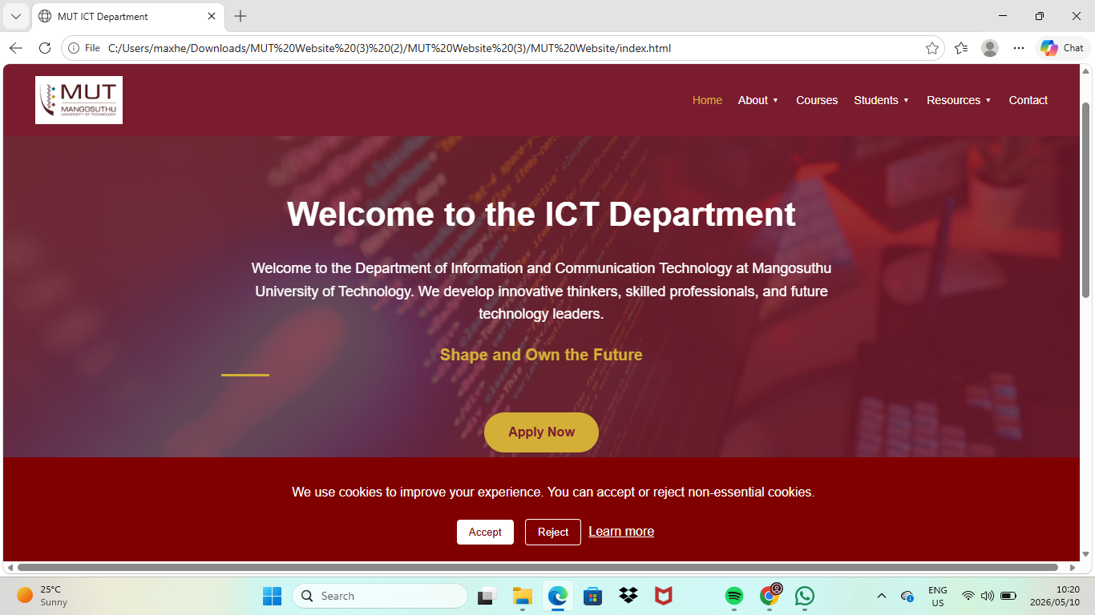

15.2 Courses Page
Displays information about ICT courses and programs.
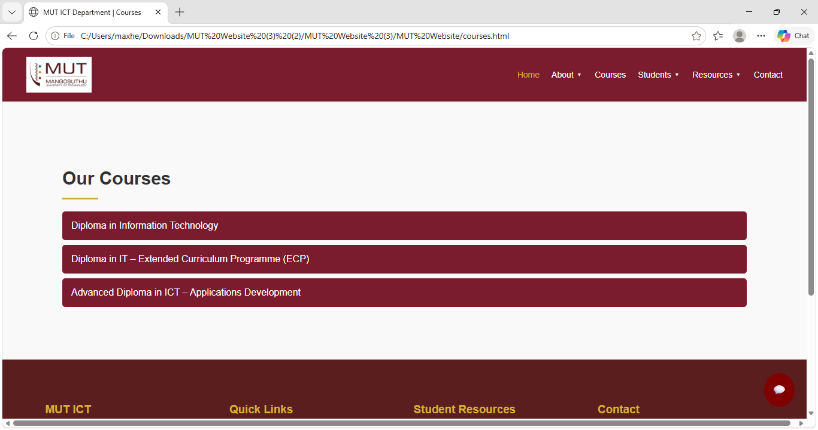

15.3 Events Page
Provides information about department events and activities.
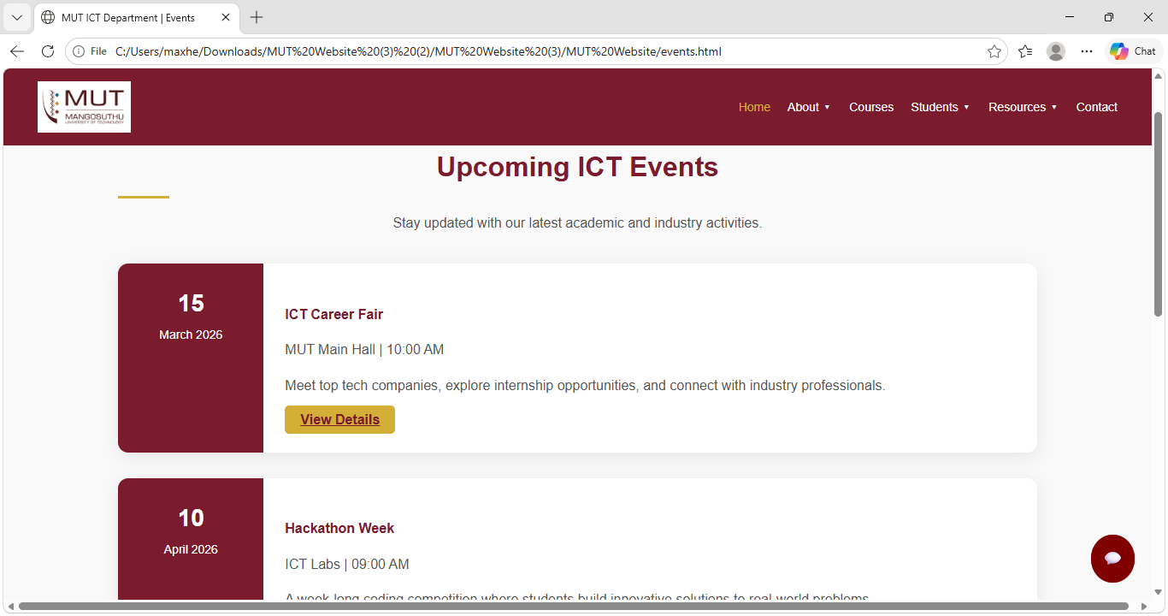

15.4 Feedback Page
Allows users to submit feedback electronically
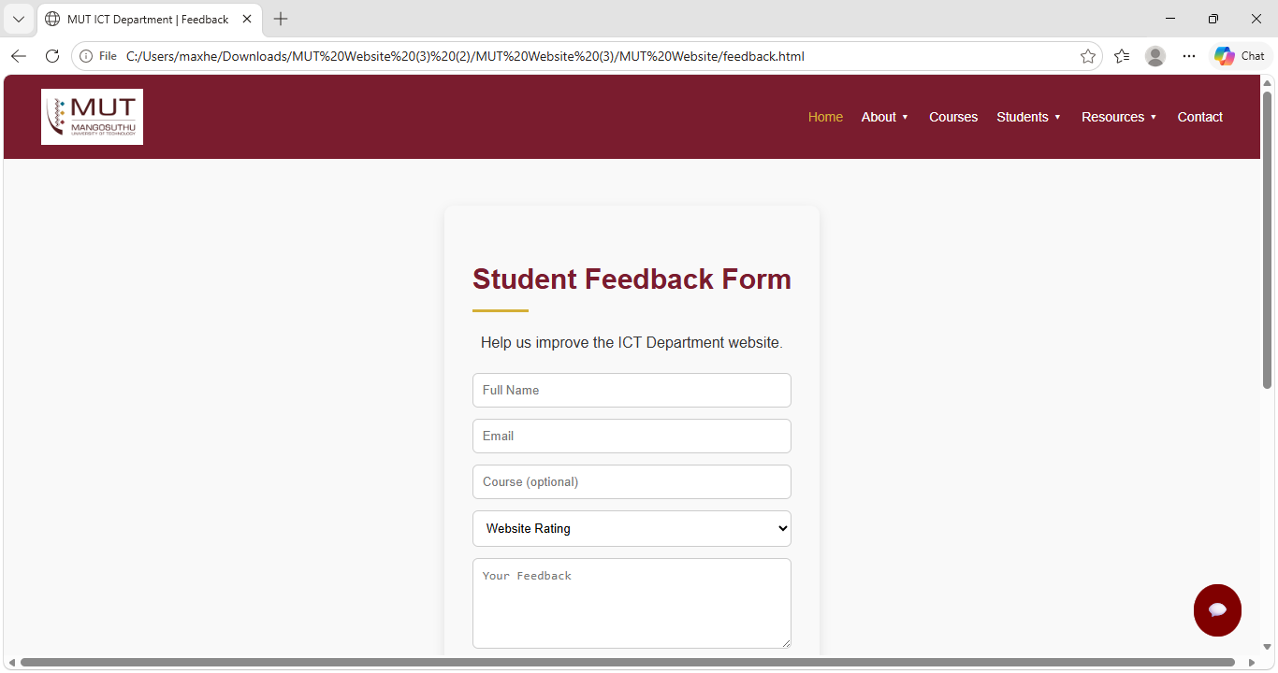

15.5 Helpdesk Page
Provides ICT support and assistance information.

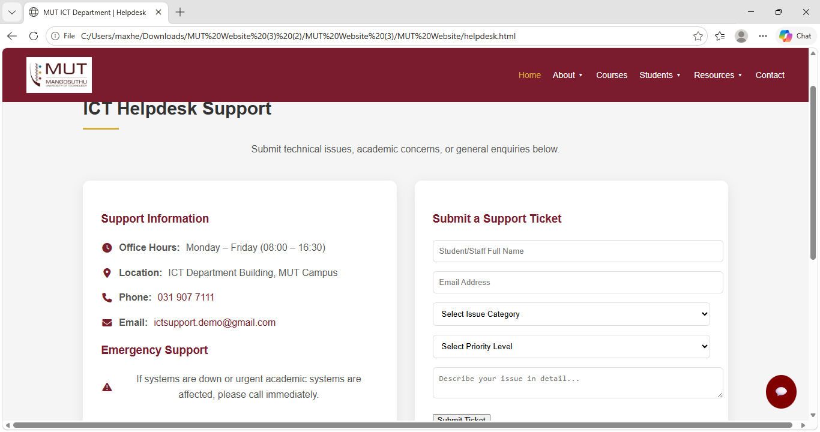

15.6 Contact Page
Allows users to send contact messages to the department.

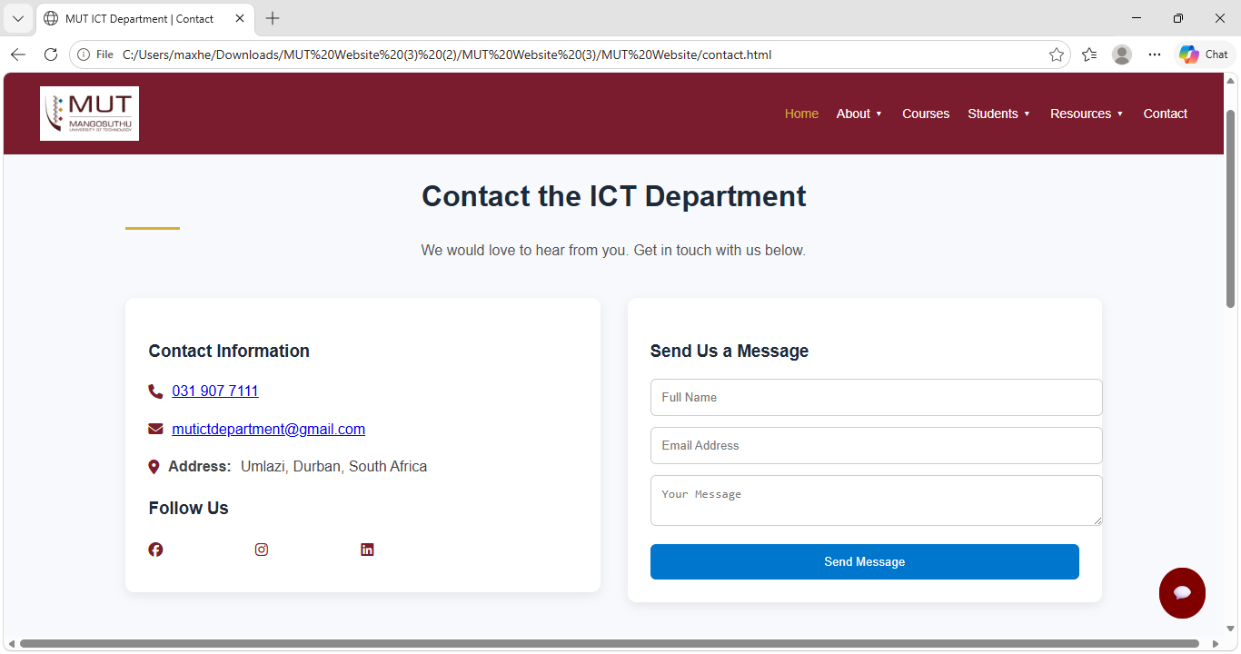
15.7 Login Page
Provides authentication functionality.
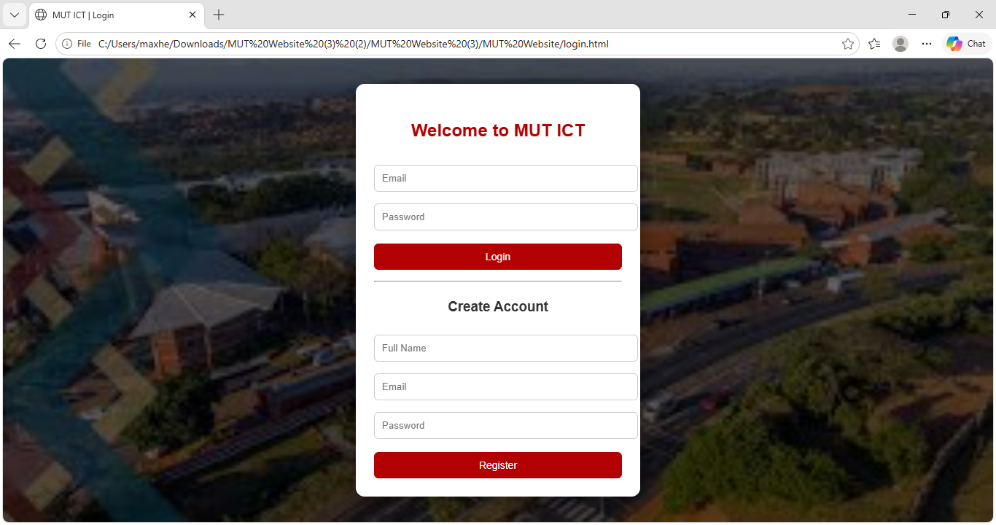

16. API Endpoints
POST /contact
Used to store contact messages in the database.
Request Example
{
"name": "John",
"email": "john@gmail.com",
"message": "Hello"
}

POST /appointment
Used to book appointments.
Request Example
{
"name": "John",
"email": "john@gmail.com",
"date": "2026-05-10",
"time": "10:00",
"type": "Consultation"
}

17. Testing and Debugging
The system was tested using:
- Browser testing
- Form submission testing
- Database connectivity testing
- API endpoint testing
- Email functionality testing
Testing Methods
Unit Testing
Individual features were tested separately.
Integration Testing
Frontend and backend communication was tested.
User Testing
The interf

18. Challenges Encountered
During the development of the MUT ICT Department Website, several challenges were experienced. These challenges affected both the frontend and backend implementation of the system. However, they were resolved through testing, debugging, and research.
18.1 Database Connectivity Issues
One of the major challenges was connecting the Node.js backend to the MySQL database. Errors such as incorrect ports, authentication problems, and failed connections occurred during development.
Solution
- Database credentials were verified.
- MySQL configuration settings were corrected.
- Proper connection handling was implemented using MySQL packages.

18.2 API Integration Problems
The communication between the frontend and backend initially produced errors because some API routes were not correctly configured.
Solution
- Express routes were restructured.
- HTTP methods such as POST and GET were corrected.
- API testing was performed using browser tools and Postman.

18.3 Form Validation
Some forms accepted incomplete or invalid data from users.
Solution
- JavaScript validation was added on the frontend.
- Backend validation was implemented to ensure data integrity.

18.4 Responsive Design Challenges
The website layout did not display properly on mobile phones and tablets during the first stages of development.
Solution
- CSS media queries were used.
- Flexible layouts and responsive containers were implemented.
- Testing was done on different screen sizes.

18.5 Email Configuration Issues
Setting up automated email notifications using Nodemailer was challenging because email authentication and permissions needed proper configuration.
Solution
- Gmail application passwords were configured.
- Secure email authentication settings were added.
- Error handling was implemented for failed emails.

18.6 File Upload Configuration
The file upload feature initially failed because uploaded files were not being stored correctly.
Solution
- Multer middleware was configured properly.
- Upload directories were created and linked correctly.

18.7 Debugging Backend Errors
The backend server occasionally crashed because of syntax errors and incorrect routing configurations.
Solution
- Console logging was used for debugging.
- Error handling middleware was implemented.
- The server was tested repeatedly after each update.

19. Future Improvements
Although the website meets the current requirements, several improvements can still be added in future versions to improve functionality and user experience.
19.1 Student Portal Integration
A complete student portal can be developed where students can:
- Log in securely
- Access results
- View timetables
- Download learning materials

19.2 Admin Dashboard
An admin dashboard can be added to allow administrators to:
- Manage website content
- View user submissions
- Monitor appointments
- Generate reports

19.3 AI Chatbot Enhancement
The current support chatbot can be improved using artificial intelligence to provide:
- Smarter responses
- Automated guidance
- Frequently asked question support
- Real-time assistance

19.4 Online Appointment Management
Users could be allowed to:
- View available appointment slots
- Cancel appointments
- Reschedule appointments online

19.5 Improved Security Features
Additional security features can be implemented, including:
- Password encryption
- Two-factor authentication
- Session management
- CAPTCHA verification

19.6 Cloud Deployment
The system can be deployed to cloud platforms such as:
- Heroku
- Render
- AWS
- Microsoft Azure
This would improve accessibility and scalability.

19.7 Mobile Application Development
A mobile application version of the system could be developed for Android and iOS users to improve accessibility.

19.8 Real-Time Notifications
The system could include real-time notifications for:
- Announcements
- Appointment reminders
- Event updates
- System alerts

20. Conclusion
The MUT ICT Department Website project successfully achieved its aim of redesigning the existing departmental website into a modern full-stack web application. The system improved the functionality, appearance, responsiveness, and interactivity of the original website.
The project demonstrated the successful integration of frontend technologies such as HTML, CSS, and JavaScript with backend technologies including Node.js, Express.js, and MySQL. Features such as forms, email notifications, database storage, responsive layouts, and support services were implemented successfully.
The website now provides users with:
- Improved communication
- Better accessibility
- Enhanced user interaction
- Responsive design for different devices
- Modern web functionality
The development process also provided practical experience in:
- Full-stack development
- API integration
- Database management
- Server-side programming
- User interface design
- Problem solving and debugging
Overall, the project provides a strong foundation for future development and demonstrates how modern web technologies can be used to improve digital services within an educational environment.

